Lantern Lane Primary
School

New Maths Curriculum
Year 4
-Objectives & Methods.

R

During year 4, your child will work on the following objectives:
- Count backwards through zero to include negative numbers.
- Recognise the place value of each digit in a four-digit number.
- Add and subtract numbers up to 4 digits using a formal written method.
- Round any number to the nearest 10, 100 or 1000.
- Recall multiplication and division facts for multiplication tables up to 12 × 12.
- Use place value, known and derived facts to multiply and divide mentally, including: multiplying by 0 and 1; dividing by 1; multiplying together three numbers.
- Recognise and use factor pairs and commutativity in mental calculations
- Multiply two-digit and three-digit numbers by a one-digit number using formal written layout.
- Use the formal written method for short division with exact answers when dividing by a one-digit number e.g. 456 ÷ 3.
- Recognise that hundredths arise when dividing an object by one hundred and dividing tenths by ten.
- Recognise and write decimal equivalents to ¼, ½ and ¾.
- Find the effect of dividing a one- or two-digit number by 10 and 100, identifying the value of the digits in the answer as ones, tenths and hundredths.
- Round decimals with one decimal place to the nearest whole number.
- Compare numbers with the same number of decimal places up to two decimal places.
- Convert between different units of measure; estimate, compare and calculate different measures, including money in pounds and pence.
- Find the area of rectilinear shapes by counting squares.
- Solve problems involving converting from hours to minutes; minutes to seconds; years to months; weeks to days.
- Compare and classify geometric shapes, including quadrilaterals and triangles, based on properties and sizes.
- Complete a simple symmetric figure with respect to a specific line of symmetry. Describe positions on a 2-D grid as coordinates in the first quadrant.
- Describe movements between positions as translations of a given unit to the left/right and up/down.

Calculation Strategies – Year 4
Addition:
- The use of the column method for addition will continue with the children working with whole numbers up to 4 digits including in context.
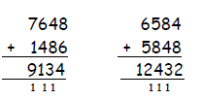
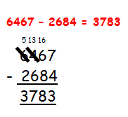
Subtraction:
Children will be introduced to and will practise the compact method of column subtraction, beginning with calculations where no decomposition is required and then working with decomposition:

The use of a number line will still be encouraged – to find small differences; where one of the numbers is a multiple of 10, 100, 1000 or when the children are working with money and finding change £5 - £3.35 = £1.65:
+5p +60p +£1

£3.35 £3.40 £4 £5

Multiplication:
- Children will build their confidence using the expanded column method for short multiplication using a larger range of two digit numbers which incorporate the full range of times table facts which are expected at this stage. They will then move to multiplying 3 digit numbers by 1 digit numbers:
127x6=(100x6)+(20x6)+(7x6)=600+120+42=762
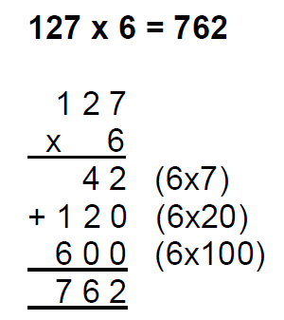
- Doubling of increasingly large numbers will be done using the partitioning and recombining method:
Double 2458 2458

2000 400 50 8

1000 200 25 4

1229
Division:
- The children will consolidate their understanding of division through the process of ‘chunking’ on a number line before developing the formal method of short division:
1 x 6 = 6
2 x 6 = 12
10 x 6 = 60
5 x 6 = 30
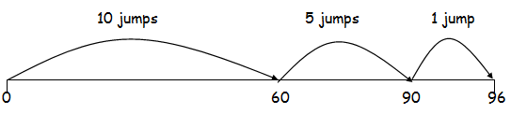
96 ÷ 6 = 16

- Formal method of short division – without a remainder within calculation.
- ÷ 3 = 32
32
3 96
- Formal method of short division – with remainders within the calculation.
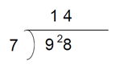
When the children are confident with the method, the dividend can be extended to 3 digit numbers, e.g 744 ÷ 6 = 124
Calculating with fractions:
- Find fractions of amounts where the numerator is greater than 0.
$\frac{3}{5}$ of 45
45 ÷ 5 = 9 3 x 9 = 27
9 | 9 | 9 | 9 | 9
- Addition and subtraction of fractions with the same denominator leading to more complex problems.
