Lantern Lane Primary
School

Supporting Your Child With The New Maths Curriculum
Year 5
-Objectives & Methods.

R

During year 5, your child will work on the following objectives:
Read, write, order and compare numbers to at least 1 000 000 and determine the value of each digit.
Add and subtract whole numbers with more than 4 digits, including using formal written methods.
Interpret negative numbers in context/ Read Roman numerals to 1000, including years.
Recognise and use square and cube numbers, and know the notation.
Use rounding to check answers and determine accuracy.
Identify multiples and factors, including finding factor pairs and common factors.
Use vocabulary: prime numbers, prime factors and composite numbers.
Know prime numbers up to 19.
Multiply and divide numbers by 10, 100 or 1000, including decimals.
Use short/ long multiplication for multiplying numbers of up to 4 digits by one or two digits.
Divide numbers using standard written short division.
Convert between mixed numbers and improper fractions.
Compare/order fractions whose denominators are multiples of the same number.
Identify, name and write equivalent fractions including tenths and hundredths. Add and subtract fractions with denominators that are multiples of the same number.
Multiply proper fractions and mixed numbers by whole numbers with support. Read and write decimal numbers as fractions.
Round decimals with 2 decimals places to whole number or to one decimal place.
Read, write, order and compare numbers with up to 3 decimal places.
Recognise % symbol and explain as a fraction with denominator 100.
Understand/use common approximate conversions between metric and imperial.
Measure and calculate the perimeter of composite rectilinear shapes.
Calculate the area of rectangles, and estimate the area of irregular shapes.
Use the properties of rectangles to find missing lengths and angles.
Distinguish between regular and irregular polygons.
Identify 3-d shapes from 2-d representations.
Know angles are measured in degrees and compare acute, obtuse and reflex angles.
Draw and measure angles to the nearest degree.
Identify angles at a point, in a turn and on a straight line.
Describe and represent the result of a reflection or translation.
Complete, read and interpret information in tables, including timetables.

Calculation Strategies – Year 5
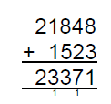
Addition:
The use of the column method for addition will continue with the children working with whole numbers up to 5 digits including in context:

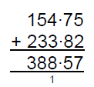
This method will also be used for adding decimal numbers including in relation to money or with decimal numbers of different lengths:
£154.75 + £233.82 = £388.57

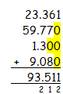
Subtraction:
The use of the column method for subtraction will continue with the children working with whole numbers up to 5 digits and decimal numbers (initially in the context of money):
£166.25 - £83.72 = £82.53
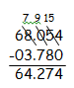
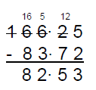
By the end of Y5, the children will be subtracting with decimals of different lengths.
68.054 – 3.78 = 64.274
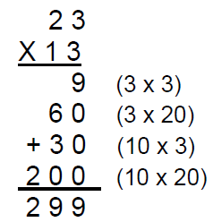
Multiplication:
Children will use the expanded column method to multiply numbers up to 4 digits by 1 or 2 digit numbers:

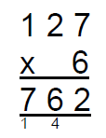
Multiplication continued:
When the children are confident with this method, they will move to the compact method initially beginning with short multiplication.

Division:
Children practise the method of short multiplication with increasingly large numbers and where there is a remainder, i.e 5309 ÷ 8 = 663 remainder 5.
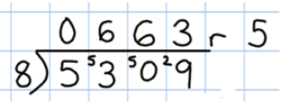
They will choose an appropriate form in which to give their answer, e.g. the answer to 5309 ÷ 8 could be expressed as 663 and five eighths, 663 r 5, or rounded as appropriate to the problem involved.
Calculating with fractions:
Children will continue to practise adding and subtracting fractions with the same denominator. Using their knowledge of equivalent fractions, they will then move to adding and subtracting fractions where one of the denominators is a multiple of the other:
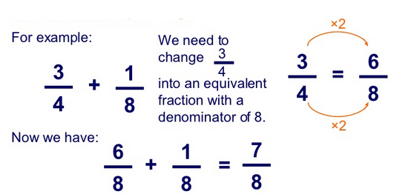

Using these skills, they will compare and order fractions whose denominators are all multiples of the same number:
Example:
5/12, 5/6, 11/12, 2/3
Lowest common multiple is 12 so all fractions converted to twelfths.
5/12, 10/12, 11/12, 8/12
Now order from smallest to largest:
5/12, 2/3, 5/6, 11/12

